How to Use Mobile Pass+ to Log into My WorkSpace

Once you have set up Mobile Pass+ on your device, you can use it to log into MyWorkSpace.

- Open Mobile Pass+ Plus on your device.
- You can use Touch ID, Face ID (if set up) or your already established 4-digit pin to authenticate to Mobile Pass+.
- You’ll see 6 numbers. This is your one-time token. It changes every 30 seconds.

- Go to https://myworkspace.ctlaccess.centurylink.com

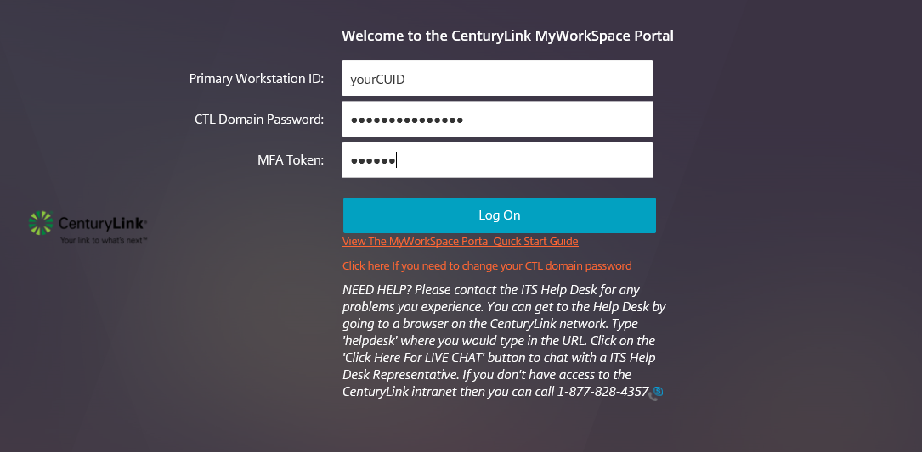

  - Enter your CUID and CTL domain password.
  - In the MFA Token field enter the 6 numbers that are currently on your Mobile Pass+
  - Click Log On
- You should now be logged into My Workspace.

